Technical Coding Research Innovation, Navi Mumbai,

Maharashtra, India-410206

(Airline Reservation System)

A Case-Study Submitted for the requirement of

**Technical Coding Research Innovation**

For the Internship Project work done during

**CORE JAVA WITH SQL INTERNSHIP PROGRAM**

by

KHEDEKAR SWARAJ SANTOSH (TCRIC3R98)

Rutuja Doiphode

CO-FOUNDER & CEO

TCR Innovation

**Abstract :-**

The Airline Reservation System is computerized system. Used to store and retrieve information and also conduct transactions related to airline travel. This project is projected towards enhancing the relationship between customers and airline agencies through the use of ARSs, and thereby making it convenient for the customers to book the flights as when they require such that they can utilize this software to make reservation.

This software has two parts, first is user and other is administrator part. In front end is develop for the user part and back end for administrator, which is used by airline authority. It will allow to access the database consist of customers and allow new customers to sign up for online access.

The system allows the airline passenger to search for flights that are available between the two travel cities, namely the “Arrival city” and “Departure city” for particular departure and arrival dates. The system displays all the flight’s details such as flight no, name, price and time etc.

After search the system display list of available flights and allows customer to choose a particular flight. To book the a flight the system asked the customer to enter his details. The system also allows the customer to cancel his/her reservation , if any problem occurs.

The main purpose of this software is to reduce the manual errors involved in the airline reservation process and make it convenient for the customers to book the flights as when they requires such that they can utilize this software to make reservations, modify reservations or cancel a particular reservation.

**Introduction : -**

The project titled Airline Reservation System is software for reservation, maintaining the data and reservation of customers. The project “Airline Reservation System” is developed in JAVA, which mainly focuses on basic operations in a reservation system like Booking of flight ticket, and data of flights , search for particular date flight info .

This “AIRLINE RESERVATION SYSTEM” project provides us with all of the essential knowledge about the reservation systems. We can add new flight details, and retrieve information about flights that are currently available in the system. We may booked the ticket and also cancel it.

The emphasis has been on presenting information and comments in a simple and understandable manner throughout the project. The project is extremely beneficial to individuals interested in learning more about Airline Reservation System.

**Problem statement and objectives :-**

Normally a person wants to reserve his ticket and he  has to contact at nearest Overseas Travels branch. The Airline Reservation System provides an interface to schedule flights and reservations for an airline through internet. Its responsibility is to keep track of system users, customers, Airbus information, flight information and cancellation.

The purpose of this project is to implement or to design a database for an airline reservation system  to check the flight details, book and cancel flight tickets. It makes the process of booking and cancelling flight tickets simple and easy for the passengers.

**Features :-**

**Search function:**

To allow the Airline Company and customers both to search for flight reservation of flight that are available and cancel if needed.

**Management of acquisitions :**

To booked flight tickets and use them.

**Management of membership:**

To keep track of the customers booking information through the database each name, Contact No, and password are saved in the Airline Reservation system. The system aids in determining the customers track record.

**Functions :-**

1. **User Login**
2. **User Signup**
3. **Password Retrieve**
4. **Add Flight**
5. **Book Ticket**
6. **Ticket Cancel**
7. **Back to login page**
8. **Search Flight Details**
9. **Exit**

**Details of hardware and software :-**

**Software Requirements :**

Operating System : Windows 8,10,11

Front End : Java

Back End : MySQL Server

**Min. Hardware Requirements :**

An Intel based central processing unit capable of running any sort of windows operating system such as Pentium based workstation.

1. Minimum 64 MB RAM (128 MB Desirable) at server.
2. Minimum 60 MB of free disk space for files.
3. A CD Rom drive
4. Minimum 48 MB of RAM at workstation.
5. VGA 15” color monitor for workstation.

**Java Programming :-**

Java is a general purpose computer programming language that is robust, high-level, objects oriented, The java swing package lets you make GUI components for your java application and it is platform independent.

The swing library is built on top of the Java Abstract Window Toolkit (AWT), an order platform dependent GUI toolkit. We can use the Java GUI components like button, scroll bar etc form the library and do not have to create the component from scratch.

**Data Access :-**

The Data Access is JDBC (MySQL Driver)

The JDBC module provides connectivity between database and java programming, so that they can communicate with each other.

**MySQL Workbench 8.0 CE :-**

MySQL Workbench is visual database designing tool that integrates SQL development, design , creation and maintenance into single integrated developed environment for MySQL

database system.

**IDE :-**

**Netbeans :**

Netbeans is an open source, tooling platform , integrated, development environment(IDE).For developing with Java, PHP and other programming languages. Netbeans is also referred as a platform of modular components used for developing java.

**CREENSHOTS OF PROJECT:**

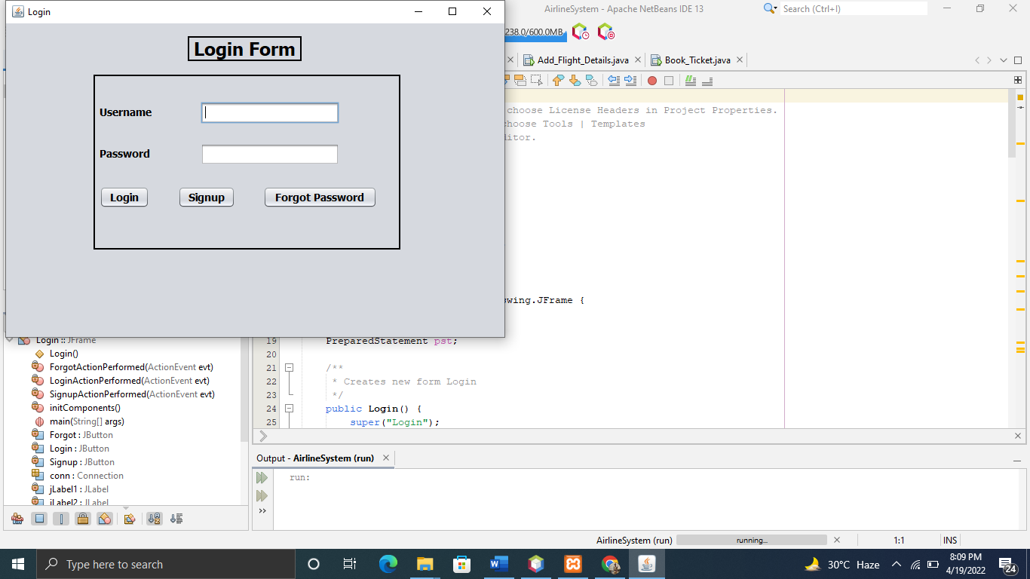**Login page :-**

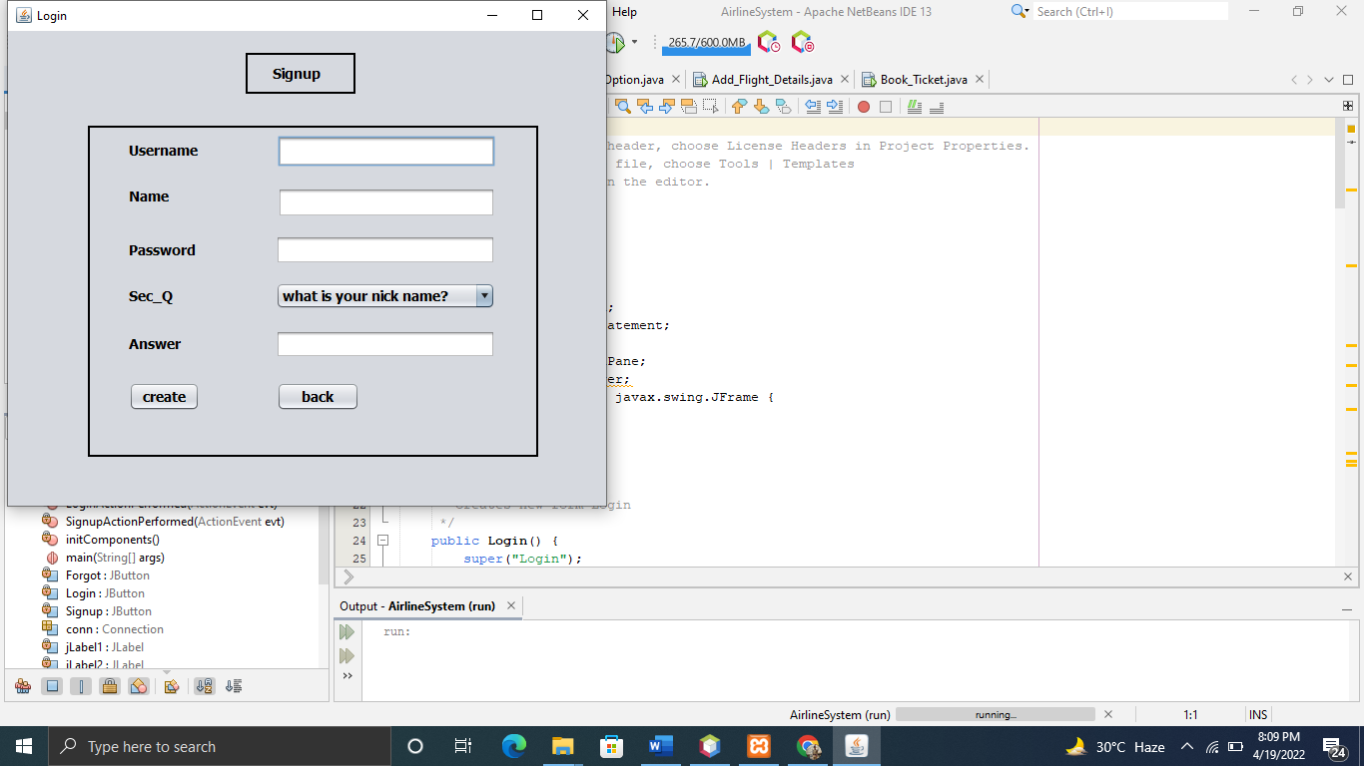

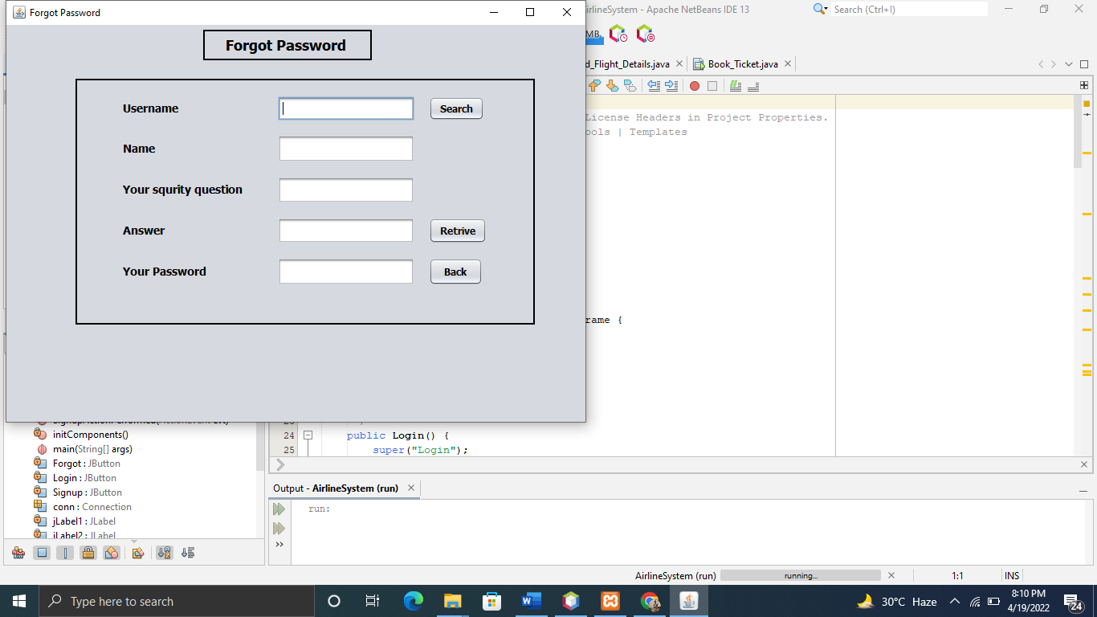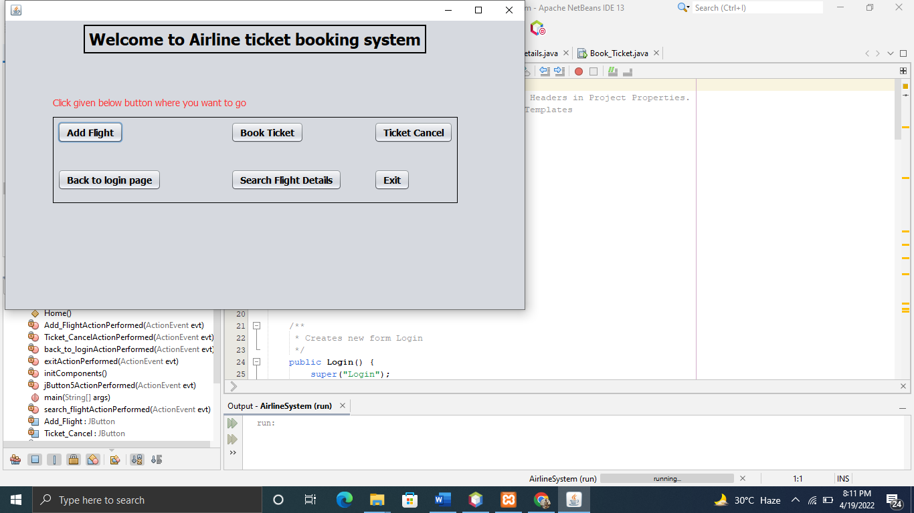

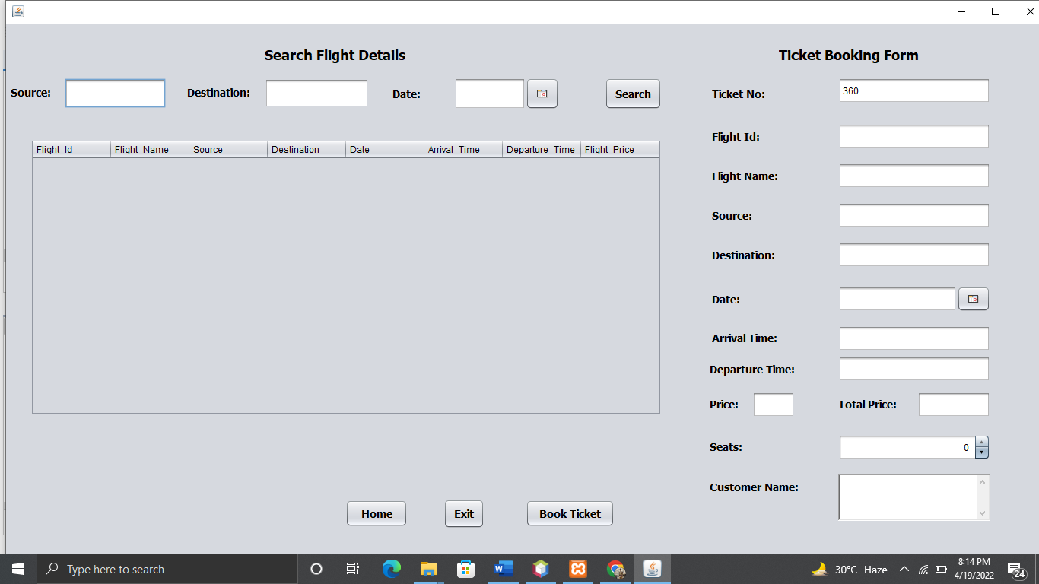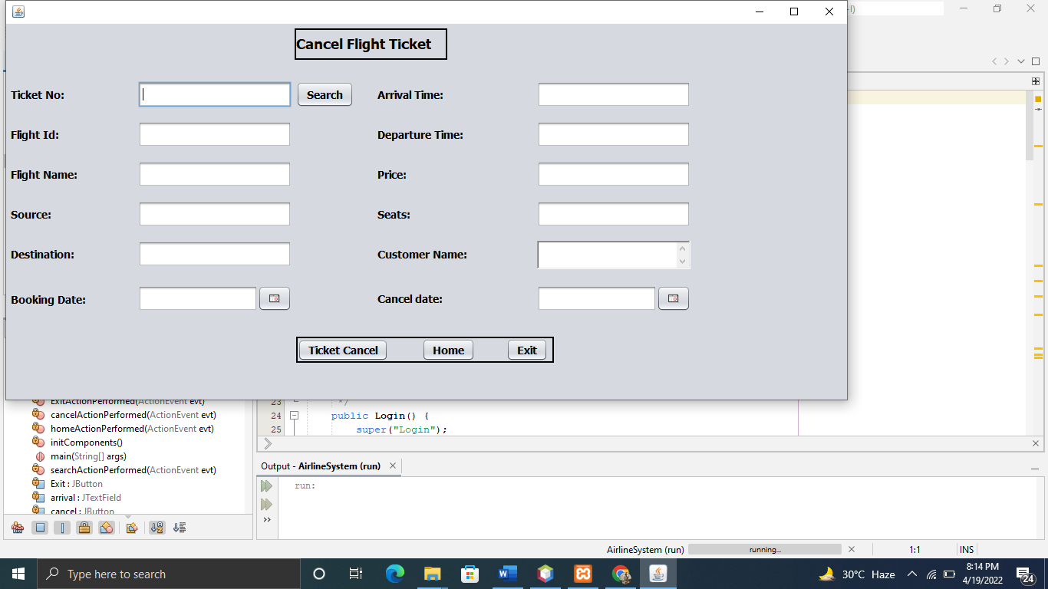

**Conclusion :-**

The Airline reservation system has been a way of minimizing the clerical work, which is almost a routine and consumes the most precious time. This AIRLINE RESERVATION SYSTEM has been an attempt to help the user to minimize his workload along with minimizing the paper works and saving of time .The system has been developed in a way to make it very user friendly. It provides an on-line message and an error detection and error messages every time the user needs. Any person having a little bit of window based can run this system without any pain.

**References :-**

* “Database Management Systems” by Raghu Ramakrishnan.
* “Database Systems Concepts, Design and Applications” by S.K.Singh.